r

1. **INTRODUCTION & MOTIVATION**
   1. **INTRODUCTION**

Counting hands was the first voting method, and it has since been replaced by paper, punch cards, mechanical levers, and optical scan devices. Modern electronic voting systems have a few characteristics that set them apart from more antiquated methods. They also offer better features than those methods, including mobility, accuracy, privacy, ease, adaptability, and verifiability. However, electronic voting methods have several problems, such being time-consuming, requiring a lot of paper labor, not involving senior officials directly, causing machine damage from neglect, preventing users from editing and updating many items at once, and so on. Thus, user can avoid data loss by putting in place a decentralized Blockchain-based server infrastructure. Using blockchain technology to hold a digital election lowers the possibility of voting-related unfairness while simultaneously saving costs. Modern technologies, like as blockchain technology, possess a high degree of security, and offer significant advantages when employed with caution. The implementation of this technology as the potential to enhance the transparency, reliability, and Monitoring of voting systems [1]. A current voting system involves a voting machine connected to a central database. This machine can be interfered with by anyone who has access to it. It may cause a single point failure in the entire voting system network; but an immutable blockchain cannot be altered by an individual traitor in the entire network.[8]

* 1. **AIM AND OBJECTIVE AIM**

Introducing a new electronic voting system with face verification that will address the shortcomings of the country's current voting practices.[1]

**OBJECTIVE**

The key objectives of the project include:

* The election system must be openly verifiable and transparent.
* The election system must ensure that the vote cast by the voter has been recorded.
* Only eligible voters must be allowed to vote.
* The election system should be tamper-proof.
* No power-hungry organization must be able to manipulate and rig the election process.
  1. **EXISTING SYSTEM**

This is the current voting system used in India. In this system vote is cast using electronics ballet. In this we cast our vote in an electronics machine. This is a group of some counter and registers. This voting system is quite easy, simple. It has advantage like mobility, secure, flexibility for election commission. But in today world all people are so much busy that they don’t have time to vote. This paper presents a perspective in the electronic voting process. That includes but not limited to identifying the polling process, The polling process the actual voting process used on the polling day.

**Blockchain setup**

To satisfy the privacy and security requirements for e-voting, and to ensure that the election system should not enable coerced voting, voters will have to vote in a supervised environment. In our work, we set up a Go-Ethereum permissioned Proof-of-Authority (POA) blockchain to achieve these goals. POA uses an algorithm that delivers comparatively fast transactions through a consensus mechanism based on identity as a stake. The reason for using Go-Ethereum for the blockchain infrastructure is explained in sub-section C. The structure of the blockchain is illustrated in Figure 1 and mainly consists of two types of nodes.

Verifying votes In the voting transaction, each voter receives the transaction ID of his vote. In this e-voting system, voters can use this transaction ID and go to an official election site (or authority) using a blockchain explorer and (after authenticating themselves using their electronic identification) locate the transaction with the corresponding transaction ID on the blockchain. Voters can, therefore, see their votes on the blockchain, and verify that the votes were listed and counted correctly. This type of verification satisfies the transparency requirements while preventing traceability of votes.

* 1. **LIMITATIONS ON EXISTING SYSTEM**

The problems of the existing manual system of voting include among others the following:

* **Expensive and Time consuming:** The process of collecting data and entering this data into the database takes too much time and is expensive to conduct, for example, time and money is spent in printing data capture forms, in preparing registration stations together with human resources, and there after advertising the days set for registration process including sensitizing voters on the need for registration, as well as time spent on entering this data to the database.
* **Too much paper work:** The process involves too much paper work and paper storage which is difficult as papers become bulky with the population size.
* **Short time provided to view the voter register:** This is a very big problem since not all people have free time during the given short period of time to check and update the voter register.

* 1. **PROPOSED SYSTEM**

The system that is suggested is the face verified online e-voting system with Face Verification using KNN algorithm and identification of voter using Block chain Address [2]. The Blockchain address is used to determine whether a particular voter is valid or not. It enables a particular voter to cast their ballot online. The polling procedure keeps going until the voting period is over, updating the server's database. Block chain addresses are used by the Face Verification online voting method to obtain all of the voter's personal information [3]. Additionally, the votes are publicly accessible and kept on a blockchain server, guaranteeing a reliable environment. When a voter inquiries to vote, the VMS, checks the voter's voting status on the blockchain through contrasting all existing transaction hashes with his or her computerized ID (Ethereum address). If a transaction's hash has been determined against the voter's ID, VMS rejects the request and logs the voter out of the system.[1]

**ADVANTAGES OF PROPOSED SYSTEM:**

* Voter can cast their votes from anywhere in the country without visiting to voting booths, in highly secured way.
* This will increase the voting percentage in India and reduces the cost of voting process.
* By using Face Verification it provides enough security which reduces the false votes.
* The collection of the results is done from the stored data on the blocks through the significant organization of the nodes in the block chain.

**Algorithm**: KNN, SHA-256

1. **PROJECT OVERVIEW**
   1. **LITERATURE SURVEY**

**Paper 1**

**Paper Name:** Secure E-Voting System using Block-chain technology and authentication via Face recognition and Mobile OTP

**Authors Name:** Q. Zhang, Palapye, Botswana

**Year of Publish: 2022**

**Explanation:**

A distributed ledger is used in blockchain which store data, making it an essential part of democracy. Web-based voting systems have evolved, making them available to all citizens, including those in rural areas. Voting ensures that each citizen has a say in a country's legislation, while decentralized systems such as blockchain ensure that transactions are linked to previous ones. The miners mine on the blockchain and get paid for their efforts. To ensure security, blockchain-based voting systems employ a decentralized chain of blocks linked by nodes, each containing a cryptographic hash, timestamp, and exchange information. A proposed solution is to store voting-related information on the blockchain and monitor users throughout the vote-taking process, with a Face Recognition System to ensure they are verified and eligible to vote.[2]

**Paper 2**

**Paper Name:** Blockchain-Based E-Voting System

**Authors Name:** Hjálmarsson, Gunnlaugur K. Hreidarsson, Mohammad Hamdaqa

**Year of Publish : 2018**

**Explanation**:

A secure electronic voting system that offers the fairness and privacy of current voting schemes, while providing the transparency and flexibility offered by electronic systems has been a challenge for a long time. In this work-in-progress paper, evaluate an application of blockchain as a service to implement distributed electronic voting systems. The paper proposes a novel electronic voting system based on blockchain that addresses some of the limitations in existing systems and evaluates some of the popular blockchain frameworks for the purpose of constructing a blockchain-based e-voting system. In particular, the paper evaluates the potential of distributed ledger technologies through the description of a case study; namely, the process of an election, and the implementation of a blockchain based application, which improves the security and decreases the cost of hosting a nationwide election[6].

**Paper 3**

**Paper Name:** Improved Face Recognition Rate Using HOG Features and SVM Classifier **Authors Name:** Harihara Santosh Dadi, Gopala Krishna Mohan Pillutla

**Year of Publish : 2019**

**Explanation:**

A novel face recognition algorithm is presented in this paper. Histogram of Oriented Gradient features are extracted both for the test image and also for the training images and given to the Support Vector Machine classifier. The detailed steps of HOG feature extraction and the classification using SVM is presented. The algorithm is compared with the Eigen feature based face recognition algorithm. The proposed algorithm and PCA are verified using 8 different datasets. Results show that in all the face datasets the proposed algorithm shows higher face recognition rate when compared with the traditional Eigen feature based face recognition algorithm. There is an improvement of 8.75% face recognition rate when compared with PCA based face recognition algorithm. The experiment is conducted on ORL database with 2 face images for testing and 8 face images for training for each person. Three performance curves namely CMC, EPC and ROC are considered. The curves show that the proposed algorithm outperforms when compared with PCA algorithm[7].

* + 1. **Comparative Analysis**

***Table 2.1.1 Comparative Analysis of Existing System***

|  |  |  |  |  |
| --- | --- | --- | --- | --- |
| **Paper Title** | **Author** | **Year** | **Publication** | **Description** |
| A Framework to Make Voting System Transparent Using Blockchain Technology | Muhammad Shoaib Farooq, Usman Iftikhar, Adel Khelif | 2022 | IEEE | Blockchain based e-voting system with Ethereum blockchain network,SHA-256 algorithm and face recognition with KNN. |
| Secure E-Voting System using Block-chain technology and authentication via Face recognition and Mobile OTP | A. Parmar, S. Gada, T. Loke, Y. Jain, S. Pathak and S. Patil | 2021 | 12th International Conference on Computing Communication and Networking Technologies (ICCCNT) | Blockchain, a distributed ledger, is crucial for democracy and web-based voting systems, ensuring citizens have a say in legislation. Decentralized systems like blockchain link transactions and ensure security. A proposed solution is to store voting-related information on the blockchain and monitor users with a Face Recognition System.. |
| E-Voting using Blockchain | Yash Dalvi, Shivam Jaiswal, Pawan Sharma | 2021 | International Journal of Engineering Research & Technology | An overview of the blockchain's fundamental properties and architecture in respect to electronic voting. |
| Improved Face Recognition Rate Using HOG Features and SVM Classifier | Harihara Santosh Dadi, Gopala Krishna Mohan Pillutla | 2019 | Iosr Journal Of Electronics And Communication Engineering (Iosr-Jece) | This paper presents an improved face recognition algorithm using HOG features and SVM classification, outperforming traditional methods by achieving an 8.75% higher recognition rat. |

* + 1. **MATHEMATICAL MODEL**

Creating a mathematical model for the K-Nearest Neighbors (KNN) algorithm in a face-verified voting system based on blockchain involves defining the key components of the system. Here's a simplified mathematical model:

**1**. **Data Representation**:

- Each voter's face data is represented as a feature vector, denoted as \(X_i\), where \(i\) represents the voter's index.

2. **Data Preprocessing**:

- Normalize and preprocess the feature vectors to ensure consistency. Let \(X_i\) be the preprocessed feature vector.

3. **Training Data:**

- The system uses a dataset of labeled facial biometric data to train the KNN algorithm.

4. **KNN Algorithm**:

- Given a new voter's feature vector \(X_{new}\) and a parameter \(K\) (number of nearest neighbors), the KNN algorithm finds the \(K\) nearest neighbors to \(X_{new\), denoted as \(N_{KNN}\).

5. **Similarity Measure**:

- Define a similarity measure, \(S(X_i, X_j)\), between two feature vectors \(X_i\) and \(X_j\). The choice of similarity measure depends on the nature of your data (e.g., Euclidean distance for numerical features, cosine similarity for embeddings).

6. **Nearest Neighbors**:

- Find the \(K\) nearest neighbors by ranking all voters based on the similarity measure:

\[N_{KNN} = \text{argmin}_{X_i} \sum_{X_j \in \text{Training Data}} S(X_{new}, X_j)\]

7. **Voting Decision**: - Aggregate the votes from the \(K\) nearest neighbors to determine the voting decision. For example, if the neighbors are classified as 'Verified' or 'Not Verified,' the majority vote among neighbors could be the decision.

8. **Blockchain Integration:**

- Integrate the voting decision into the blockchain-based voting system, recording the voter's decision and the verification process.

9. **Decision Threshold**:

- You may set a decision threshold for the KNN algorithm, indicating how many of the \(K\) neighbors must vote 'Verified' for the new voter to be 'Verified.'

**Mathematical Formulation:**

The mathematical model for the KNN algorithm in this context involves defining the similarity measure, which can vary based on the features used. For instance, if using the Euclidean distance as the similarity measure for numerical feature vectors, it can be defined as:

\[S(X_i, X_j) = \sqrt{\sum_{k=1}^{n} (X_{i_k} - X_{j_k})^2}\]

Where \(n\) is the dimensionality of the feature vectors, and \(X_{i_k}\) and \(X_{j_k}\) are the \(k\)-th components of the vectors \(X_i\) and \(X_j\).

The decision threshold may be a value indicating the maximum acceptable distance or a specific number of neighbors required to vote 'Verified.'

This mathematical model serves as a conceptual framework.

In a face-verified voting system based on blockchain, the SHA-256 (Secure Hash Algorithm 256-bit) is used for securing and hashing critical data, such as voter identities and voting records. Here's a simplified mathematical model for the SHA-256 algorithm in this context:

**SHA-256 algorithm**

**1. Data Representation:**

Data, such as voter identities and voting records, is represented as a binary string or bytes. Let's denote this data as *D*.

**2. SHA-256 Algorithm:**

The SHA-256 algorithm takes the binary data *D* as input and computes a fixed-length 256-bit hash value *H*:

*H*=SHA-256(*D*)

**3. Mathematical Formulation:**

The SHA-256 algorithm processes the input data *D* in blocks and performs several bitwise operations, rotations, and modular additions. The details of the algorithm are quite complex but can be summarized mathematically as follows:

*H*=SHA-256(*D*)=SHA-256(*D*0​,*D*1​,*D*2​,…,*Dn*​)

Where *D*0​,*D*1​,*D*2​,…,*Dn*​ are the blocks of data.

The SHA-256 algorithm operates on each block using a series of logical functions, modular additions, bitwise shifts, and constants. It transforms the input data into the 256-bit hash *H*.

**4. Security and Properties:**

The SHA-256 algorithm is designed to have several important properties, including:

**Deterministic**: The same input data will always produce the same hash value.

**Pre-image resistance**: It should be computationally infeasible to reverse the hash function to find

the original input data from its hash.

**Collision resistance**: It should be highly improbable that two different inputs produce the same hash value.

**Avalanche effect**: A small change in the input should result in a significantly different hash value.

**Efficiency**: The algorithm should be computationally efficient, making it difficult to find two different inputs with the same hash value (a collision).

These properties ensure that the SHA-256 hash is a secure and reliable way to represent data in a tamper-evident manner on a blockchain.

**1. User Registration & Trained Voter Face:**

User should register in our website *(User Voting Page Way)* Block chain as an initial step with their mobile name, email, aadhar id, Voter id , image Area, Block chain Address contact number to which an unique *USER-ID* register. Users who are all registered in this portal are also considered as voter. The voter image convert to trained image After registering successfully the admin verify the voter details, after user can login into their profile using their *USER-ID* and their registered password.

**Admin:**

Admin Login page with default user name and password. Admin can accept or reject an voter request by verifying the user detail and also admin can register another admin. User has to scan his aadhar card for verification process. After scanning he should enter his detail and send an request to the admin if the account get rejected due to some reason he will be intimated to register again by admin.

**2. Create Election**

The Admin can create an election with election type and election constituency. All the election gets triggered at the given date and time. And Verified user has to login and scan his Block chain Address if election and user constituency matches user can view Election details. And Block chain Address. To create Nominated account in block chain.

**3. Voting**

Voters must have access to any web browser to take part in voting. The voter's interface would be provided in English language to make it easy to use for all users. The proposed system can contain a large number of voters at the time of voting. A decentralized block chain system enables a voter to vote from any part of the world. A person can take part in voting from anywhere, even if he is in a foreign country, in this way his/her computerized National ID is verified from the national database so he can cast the vote. User has to face his registered finger during his

registration process. In voting page voter has to scan his face if the User Face matches with registered Face , voter can cast his or her vote to the right candidate Source KNN an algorithm for recognition of human face is used to compare two Face. Voting transactions are sent to a pool from which miners analyze them and remove the malicious request by taking the consensus from the other nodes before adding it to the chain. The votes are fully secured using a cryptographic hash. Each vote cast adds a new block in the chain. When the transaction completes and a node is successfully added to Vote Chain, the voter of that particular voting transaction is notified through an SMS to his registered email. The voter has provided with a unique transaction hash by which he can verify his vote through a web portal and upon successfully completion of transaction the vote has been counted in the whole voting activity.

**4. Publish Result**

Smart contracts are providing a secure connection between the user and the network while executing a transaction in the chain. These are the rules that are implemented on the entire Block chain and cannot be neglected under any condition. All the nodes have to follow the smart contracts to save the vote in the system successfully. When user completes his or her voting process votes are stored in Block chain. So the voter can trust his votes stored in block chain cannot be changed. User can view his or her vote in a pie chart retrieved from block chain.SHA256 algorithm has been used to hash the data. Admin Can publish the result of each constituency after the election process is fully completed.

* 1. **PROBLEM STATEMENT**

Creating a robust facial recognition system that can accurately verify a voter's identity, ensuring that each eligible voter can only cast one vote and minimizing the potential for impersonation or fraud. Employing blockchain technology to establish an immutable and transparent ledger for recording votes. This ledger must be resistant to tampering and allow for public verification of the results, enhancing trust in the election process. Employing blockchain technology to establish an immutable and transparent ledger for recording votes. This ledger must be resistant to tampering and allow for public verification of the results, enhancing trust in the election process[1].

* 1. **SYSTEM OVERVIEW**
* **User** :

User should register in our website *(User Voting Page Way)* Block chain as an initial step with their mobile name, email, aadhar id, Voter id , image Area, Block chain Address contact number to which an unique *USER-ID* register. Users who are all registered in this portal are also considered as voter. The voter image convert to trained image After registering successfully the admin verify the voter details, after user can login into their profile using their *USER-ID* and their registered password

* **Admin:**

Admin Login page with default user name and password. Admin can accept or reject an voter request by verifying the user detail and also admin can register another admin. User has to scan his aadhar card for verification process. After scanning he should enter his detail and send an request to the admin if the account get rejected due to some reason he will be intimated to register again by admin.

* **Create Election**

The Admin can create an election with election type and election constituency. All the election gets triggered at the given date and time. And Verified user has to login and scan his Block chain Address if election and user constituency matches user can view Election details. And Block chain Address. To create Nominated account in block chain.

* **Publish Result**
* Smart contracts are providing a secure connection between the user and the network while executing a transaction in the chain. These are the rules that are implemented on the entire
* Block chain and cannot be neglected under any condition. All the nodes have to follow the smart contracts to save the vote in the system successfully. When user completes his or her voting process votes are stored in Block chain. So the voter can trust his votes stored in block chain cannot be changed. User can view his or her vote in a pie chart retrieved from block chain.SHA256 algorithm has been used to hash the data. Admin Can publish the result of each constituency after the election process is fully completed[1].
  1. **PROJECT TIMELINE CHART**

***Fig.2.4 Project Timeline Chart***

* 1. **TASK DISTRIBUTION**
     1. **DESIGN PHASE**

***Table No 2.5.1: Design Phase***

|  |  |  |
| --- | --- | --- |
| **Name of Student** | **Task Performed** | **Result** |
| **Gaurav V. Jadhav** | Project Design | Completed Successfully |
| **Aakash L. Desale** | Suggested Appropriate contents | Completed Successfully |
| **Nitesh N. Sawardekar** | Documentation | Completed Successfully |

* + 1. **IMPLEMENTATION PHASE**

***Table No 2.5.2****:* ***Implementation Phase***

|  |  |  |
| --- | --- | --- |
| **Name of Student** | **Implementation Task** | **Result** |
| **Gaurav V. Jadhav** | Project Implementation | Completed Successfully |
| **Aakash L. Desale** | Implemented Project Algorithm. | Completed Successfully |
| **Nitesh N. Sawardekar** | Documentation | Completed Successfully |

1. **SOFTWARE REQUIREMENT SPECIFICATION**
   1. **HARDWARE REQUIREMENTS**

System : Intel Core i3 2.00 GHz.

Hard Disk : 1 TB.

Monitor : 14’ Color Monitor.

Mouse : Optical Mouse.

Ram : 4 GB.

Keyboard : 101 Keyboard Keys.

* 1. **SOFTWARE REQUIREMENTS**

Operating system : Windows 10 and above.

Coding Language : Python

Software’s used : eclipse IDE, Python 3.6.3

XAMPP, Ganache.

Languages Used : JavaScript, HTML, CSS, PHP, Python, Solidity

Technology Used : Blockchain

Algorithms : SHA-256,

KNN (K-NEAREST NEIGHBOURS)

1. **SYSTEM DESIGN**
   1. **DESIGN SPECIFICATION**
      1. **ALGORITHM**

**Step 1: Start**

**Step.2: Face Recognition using k-nearest neighbors**

def predict(self, X):

y_pred = [self._predict(x) for x in X]

return np.array(y_pred)

def _predict(self, x):

distances = [euclidean_distance(x, x_train) for x_train in self.X_train]

k_indices = np.argsort(distance)[:self.k]

k_nearst_labels = [self.y-train[i] for i in k_indies]

most_common= np.bincount(k_nearest_labels).argmax()

return most_common

**Step 3: Voter Registration using Blockchain address**

Require: Initialization of parameters

Initialize voter id = this voter_id

Initialize voter name = this voter_name

Func (Register Voter)

Input: voter id

Require: voter_id =! Null

If voter_id exist

then revert back to voter id else

if voter_age < 18

then revert back to voter id else

Add Voter successfully

End Func

End Smart Contract

**Step 4: Voter identification Vote casting using SHA-256:**

mapping(address => Voter) public voters;

event Voted(adress indexed voter, uint256 vote);

function vote(uint256 _vote) public {

require(!voters[msg.sender].hasVoted, "Voter has already voted");

voters[msg.sender].hasVoted = true;

voters[msg.sender].vote = _vote;

emit Voted(msg.sender, _vote);}

**Step 5 : Stop**

* + 1. **WORKING OF ALGORITHM**

The general idea of working of proposed system algorithm is given as bellows:

Step 1: Start

This is just the beginning of the algorithm, indicating the start of the process.

Step 2: Face Recognition using k-nearest neighbors

This step involves face recognition using the k-nearest neighbors algorithm. The algorithm predicts the label of a given input image by finding the k nearest images in the training dataset and taking a majority vote among their labels.

Step 3: Voter Registration using Blockchain address

This step involves registering a voter using a blockchain address. It seems to define a smart contract that initializes parameters such as voter ID and name, and then provides a function to register a voter by checking if the ID exists and if the age is above 18. If the conditions are met, the voter is successfully added to the registry.

Step 4: Voter identification and Vote casting using SHA-256

This step utilizes blockchain technology for voter identification and vote casting. It defines a mapping between addresses and voters in a smart contract. The vote function allows a voter to cast their vote by specifying their choice. It checks if the voter has already voted, records their vote, and emits an event indicating the vote.

Step 5: Stop

This marks the end of the algorithm.

* 1. **SYSTEM ARCHITECTURE**



**Admin**

**Add Election**

**Publish Result**

**Verify User**

**Register**

**Vote for Candidate**

**Trained Image**

**Upload image**

**User**

**Result**

**Register Vote**

**Face Verification**



***Fig.4.2: System Architecture for e-Voting System***

* 1. **DATA FLOW DIAGRAM**

Display warning message

Display voter’s info

Check if already voted or not

***Fig. 4.3.1: DFD Level 0 for e-Voting System***

Voter’s Details

Comparison

Face verification in block chain Database

Display warning

Voting process

***Fig. 4.3.2: DFD Level 1 for e-Voting System***

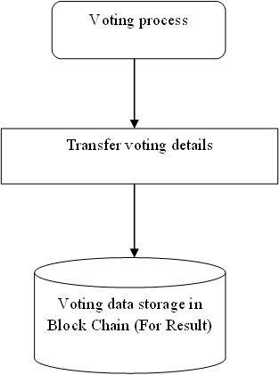

***Fig. 4.3.3: DFD Level 2 for e-Voting System***

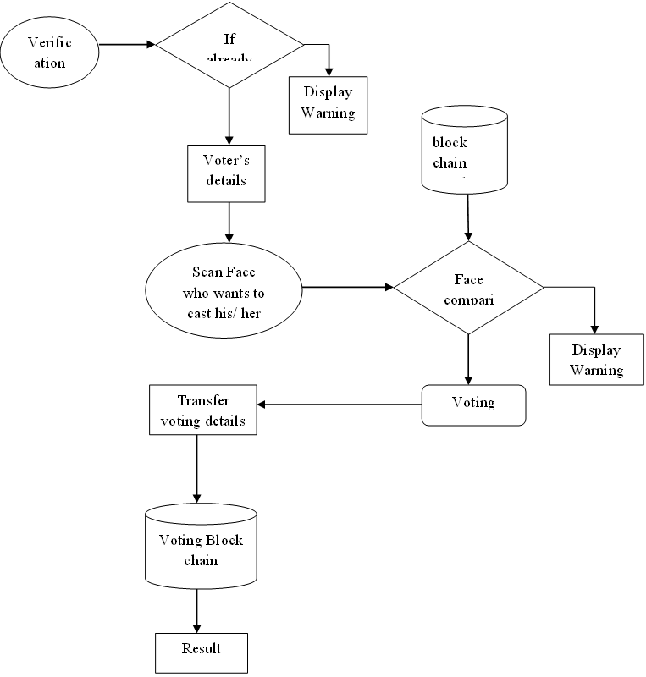

***Fig. 4.3.4: DFD Level 3 for e-Voting System***

* 1. **FLOW CHART**

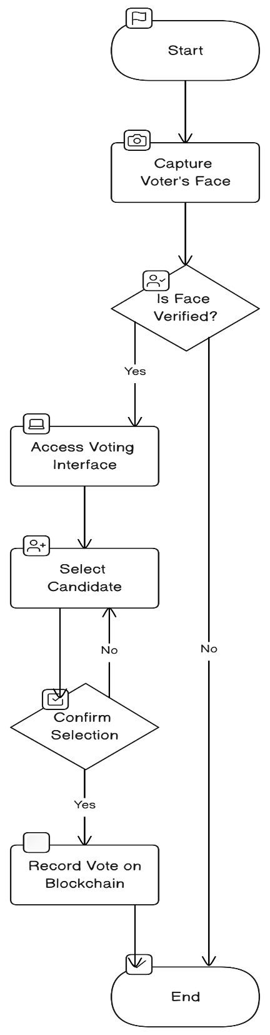

***Fig. 4.4: Flowchart of e-Voting System***

* 1. **UML DIAGRAMS**
     1. **CLASS DIAGRAM**

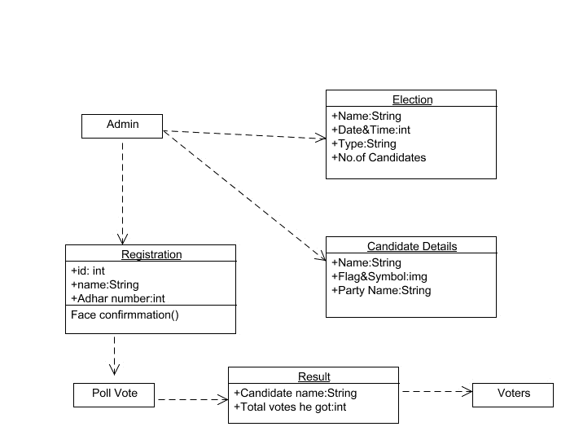

***Fig. 4.5.1 Class Diagram for e-Voting System***

3 :

* + 1. **SEQUENCE DIAGRAM**

***Fig. 4.5.2 Sequence Diagram for e-Voting System***

* + 1. **Use Case Diagram**

***Fig. 4.5.3 Use Case Diagram for e-Voting System***

* + 1. **ACTIVITY DIAGRAM**

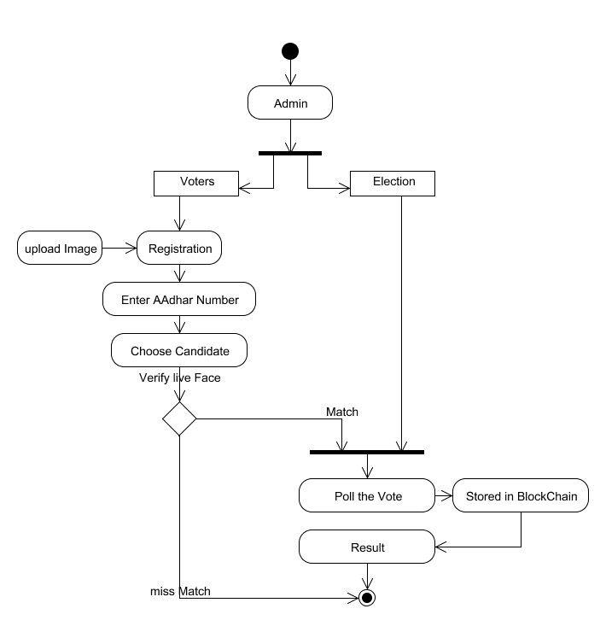

***Fig. 4.5.4 Activity Diagram e-Voting System***

* + 1. **COLLABORATION DIAGRAM**

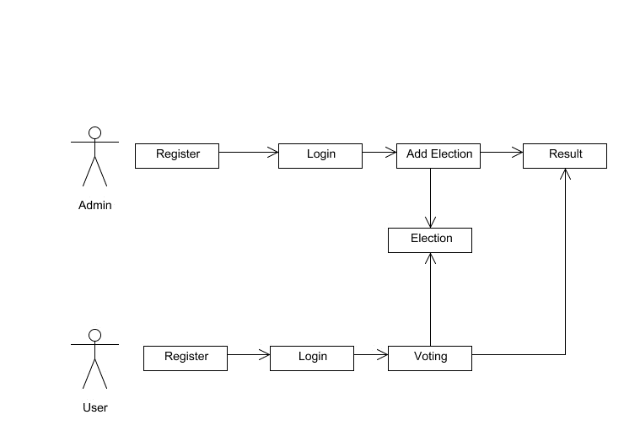

***Fig. 4.5.5 Collaboration Diagram for e-Voting System***

1. **PROJECT IMPLEMENTATION**
   1. **TECHNOLOGY OVERVIEW**

**PYTHON**

Python is a general-purpose interpreted, interactive, object-oriented, and high-level programming language. An interpreted language, Python has a design philosophy that emphasizes code readability (notably using whitespace indentation to delimit code blocks rather than curly brackets or keywords), and a syntax that allows programmers to express concepts in fewer lines of code than might be used in languages such as C++ or Java. It provides constructs that enable clear programming on both small and large scales. Python interpreters are available for many operating system. CPython, the reference implementation of Python, is open-source software and has a community-based development model, as do nearly all of its variant implementations. CPython is managed by the non-profit python software foundation. Python features a dynamic type system and automatic memory management. It supports multiple programming paradigms, including object oriented , imperative, functional and procedural, and has a large and comprehensive standard library.

**Bloch-chain**

Blockchain is a distributed ledger technology that enables secure, transparent, and immutable record-keeping of transactions across a network of computers. Each block in the chain contains a number of transactions, and every time a new transaction occurs, a record of that transaction is added to every participant’s ledger.

Key Features:

Decentralization: Unlike traditional centralized systems where a single authority controls the data, blockchain operates on a decentralized network of computers (nodes). This eliminates the need for a central authority, making the system more resilient and less prone to manipulation.

Transparency: The entire transaction history is recorded on a public ledger that is

accessible to all participants. This transparency helps to build trust among users as they can verify the authenticity of transactions.

Immutability: Once a transaction is recorded on the blockchain, it cannot be altered or deleted. Each block contains a unique cryptographic hash of the previous block, making it extremely difficult to tamper with historical data without the consensus of the majority of participants.

Security: Blockchain uses cryptographic techniques to secure transactions and protect the integrity of the network. Each participant has a private key to sign transactions, and consensus mechanisms ensure that only valid transactions are added to the ledger.

Types of Blockchain:

Public Blockchain: Anyone can participate in a public blockchain network, and the data is accessible to anyone. Bitcoin and Ethereum are examples of public blockchains.

Private Blockchain: In a private blockchain, access is restricted to a specific group of participants. It is often used by businesses and organizations to maintain privacy and control over the network.

Consortium Blockchain: A consortium blockchain is controlled by a group of organizations rather than a single entity. It offers a balance between the openness of public blockchains and the control of private blockchains.

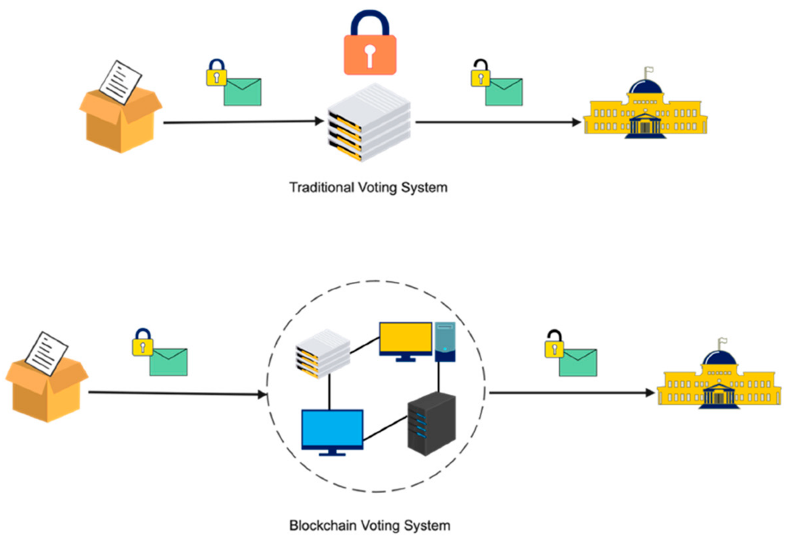

* 1. **CODING**

**face_recognition_knn_web.py**

import os

import json

from math import sqrt

#from sklearn import neighbors

from sklearn.neighbors import KNeighborsClassifier

from os import listdir

from os.path import isdir, join, isfile, splitext

import pickle

from PIL import Image, ImageFont, ImageDraw, ImageEnhance

import face_recognition

from face_recognition import face_locations

from face_recognition.cli import image_files_in_folder

#This is not working for me

#from face_recognition.face_recognition_cli import image_files_in_folder

#comment this line if you got error

from flask import Flask, jsonify, request, redirect,render_template

from flask_cors import CORS

from os import path

ALLOWED_EXTENSIONS = {'png', 'jpg', 'jpeg'}

REGISTER_PATH="./Register/"

TEMP_PATH="./Temp/"

if not os.path.exists(REGISTER_PATH):

os.makedirs(REGISTER_PATH )

app = Flask(__name__)

CORS(app)

def allowed_file(filename):

return '.' in filename and \

filename.rsplit('.', 1)[1].lower() in ALLOWED_EXTENSIONS

@app.route('/register', methods=['GET', 'POST'])

def upload_register():

# Check if a valid image file was uploaded

if request.method == 'POST':

if 'file' not in request.files:

return json.dumps({"status": "Error", "msg": "Image cannot be empty "})

name = request.form.get('name')

email = request.form.get('email')

if(name ==''):

return json.dumps({"status": "Error", "msg": "Name cannot be empty "})

file = request.files['file']

# src = path.realpath(REGISTER_PATH+"/"+email+"/"+name+"/"+file.filename)

print(name)

print(file)

if file.filename == '':

return json.dumps({"status": "Error", "msg": "Image cannot be empty "})

if file and allowed_file(file.filename):

if os.path.exists(REGISTER_PATH+email):

#file.save(REGISTER_PATH+email+"/"+file.filename)

foo = Image.open(file)

#foo = foo.rotate(90, PIL.Image.NEAREST, expand = 1)

foo.save(REGISTER_PATH+email+"/"+file.filename.strip(),optimize=True,quality=85)

os.rename(REGISTER_PATH+email+"/"+file.filename,REGISTER_PATH+email+"/"+name+".jpg")

#return json.dumps({"status": "Error", "msg": "User Already Registered"})

else:

os.makedirs(REGISTER_PATH+email)

foo = Image.open(file)

#file.save(REGISTER_PATH+email+"/"+file.filename)

#foo = foo.rotate(90, PIL.Image.NEAREST, expand = 1)

foo.save(REGISTER_PATH+email+"/"+file.filename.strip(),optimize=True,quality=85)

os.rename(REGISTER_PATH+email+"/"+file.filename,REGISTER_PATH+email+"/"+name+".jpg")

print(file)

return json.dumps(train(REGISTER_PATH))

else:

return json.dumps({"status": "Error", "msg": "Image Format not supported <png,jpg,jpeg> "})

# If no valid image file was uploaded, show the file upload form:

return json.dumps ({"status":"Error","msg":"GET Not Allowed "})

@app.route('/', methods=['GET', 'POST'])

def upload_image():

# Check if a valid image file was uploaded

if request.method == 'POST':

if 'file' not in request.files:

return redirect(request.url)

file = request.files['file']

if file.filename == '':

return redirect(request.url)

foo = Image.open(file)

if file and allowed_file(file.filename):

# The image file seems valid! Detect faces and return the result.

print(file)

#foo = foo.rotate(90, PIL.Image.NEAREST, expand = 1)

foo.save(TEMP_PATH+"/"+file.filename.strip(),optimize=True,quality=85)

return json.dumps(predict(file))

# If no valid image file was uploaded, show the file upload form:

return render_template('index.html')

def predict(X_img_path, knn_clf = None, model_save_path ="train", DIST_THRESH = .5):

# if not isfile(X_img_path) or splitext(X_img_path)[1][1:] not in ALLOWED_EXTENSIONS:

# raise Exception("invalid image path: {}".format(X_img_path))

if knn_clf is None:

with open(model_save_path, 'rb') as f:

knn_clf = pickle.load(f)

# X_img = face_recognition.load_image_file(X_img_path)

#X_img = face_recognition.load_image_file(X_img_path)

X_img = face_recognition.load_image_file(TEMP_PATH+X_img_path.filename)

X_faces_loc = face_locations(X_img)

if len(X_faces_loc) == 0:

return []

faces_encodings = face_recognition.face_encodings(X_img, known_face_locations=X_faces_loc)

closest_distances = knn_clf.kneighbors(faces_encodings, n_neighbors=1)

is_recognized = [closest_distances[0][i][0] <= DIST_THRESH for i in range(len(X_faces_loc))]

return [{"result":pred,"status":str(rec)} if rec else {"result":"N/A","status":str(rec)} for pred, loc, rec in zip(knn_clf.predict(faces_encodings), X_faces_loc, is_recognized)]

def train(train_dir, model_save_path="train", n_neighbors=None, knn_algo='ball_tree', verbose=False):

X = []

y = []

for class_dir in listdir(train_dir):

if not isdir(join(train_dir, class_dir)):

continue

for img_path in image_files_in_folder(join(train_dir, class_dir)):

image = face_recognition.load_image_file(img_path)

faces_bboxes = face_locations(image)

if len(faces_bboxes) != 1:

if verbose:

print("image {} not fit for training: {}".format(img_path, "didn't find a face" if len(

faces_bboxes) < 1 else "found more than one face"))

continue

X.append(face_recognition.face_encodings(image, known_face_locations=faces_bboxes)[0])

y.append(class_dir)

if n_neighbors is None:

n_neighbors = int(round(sqrt(len(X))))

if verbose:

print("Chose n_neighbors automatically as:", n_neighbors)

#knn_clf = neighbors.KNeighborsClassifier(n_neighbors=n_neighbors, algorithm=knn_algo, weights='distance')

knn_clf = KNeighborsClassifier(n_neighbors=n_neighbors, algorithm=knn_algo, weights='distance')

knn_clf.fit(X, y)

if model_save_path != "":

with open(model_save_path, 'wb') as f:

pickle.dump(knn_clf, f)

return {"status":"Success","msg":"Trained successfully"}

if __name__ == "__main__":

app.run(host='0.0.0.0', port=5001, debug=True)

1. **TESTING**
   1. **SYSTEM TESTING**

***Table no. 6.1: Test Cases***

|  |  |  |  |  |
| --- | --- | --- | --- | --- |
| **Sr no.** | **Test Case** | **Expected Result** | **Result** | **Remark (if fail)** |
| 1 | User Register | If User registration successfully. | Pass | If already user email exist, then it fails. |
| 2 | User Login | If Username and password is correct, then it will getting valid page. | Pass | Un Register Users will not logged in. |
| 3 | Admin login | Admin can login with his login credential. If success he get his home page | Pass | Invalid login details will not allowed here |
| 4 | Admin can activate the register users | Admin can activate the register user id | Pass | If user id not found then it won’t login |
| 7 | Blockchain public Address | Obtaining Unique Hash value | Pass | Receiving Unique Hash Value using Blockchain from Ganache Server |
| 5 | Face Recognition | If face is Recognised | Pass | If Face is not Valid then voter cannot cast vote |
| 6 | Input Aadhar Feed by the user | Valid Aadhar number is accepted as enrolled in Database | Pass | Invalid User Not Allowed |

1. **RESULTS AND DISCUSSIONS-**
   1. **RESULTS SETS**

***TABLE 7.1.1 TESTING PERFORMANCE ON TRAIN SET***

Testing with k = 1

|  |  |  |  |  |
| --- | --- | --- | --- | --- |
| **Test** | **Precision** | **Recall** | **Fl-score** | **Support** |
| A | 1.0 | 0.50 | 0.67 | 2.00 |
| B | 0.67 | 1.00 | 0.80 | 2.00 |
| C | 1.0 | 1.00 | 1.0 | 2.00 |
| D | 0.67 | 1.00 | 0.80 | 2.00 |
| E | 1.0 | 0.50 | 0.67 | 2.00 |
| F | 0.67 | 1.00 | 0.80 | 2.00 |
| G | 1.0 | 1.00 | 1.0 | 2.00 |
| H | 1.00 | 0.50 | 0.67 | 2.00 |
| I | 1.00 | 1.0 | 1.0 | 2.00 |
| H | 0.50 | 1.00 | 0.67 | 2.00 |
| K | 1.0 | 0.50 | 0.67 | 2.00 |
| L | 1.0 | 1.00 | 1.0 | 2.00 |
| M | 0.50 | 0.50 | 0.50 | 2.00 |
| N | 1.0 | 1.00 | 1.0 | 2.00 |
| O | 1.0 | 1.00 | 1.0 | 2.00 |
| P | 0.33 | 0.50 | 0.40 | 2.00 |
| Q | 0.67 | 1.0 | 0.80 | 2.00 |
| R | 1.0 | 1.0 | 1.0 | 2.00 |
| S | 1.0 | 1.0 | 1.0 | 2.00 |
| T | 0.50 | 1.0 | 0.67 | 2.00 |
| **Average** | **0.83** | **0.85** | **0.81** | **2.00** |

***TABLE7.1.2 TESTING PERFORMANCE ON VALIDATION SET***

Testing with k = 2

|  |  |  |  |  |
| --- | --- | --- | --- | --- |
| **Test** | **Precision** | **Recall** | **Fl-score** | **Support** |
| A | 0.33 | 0.5 | 0.4 | 2 |
| B | 0.5 | 0.5 | 0.5 | 2 |
| C | 0.5 | 1 | 0.67 | 2 |
| D | 0.33 | 0.5 | 0.4 | 2 |
| E | 0.33 | 0.5 | 0.4 | 2 |
| F | 0.5 | 1.0 | 0.67 | 2 |
| G | 1.0 | 1.0 | 1.0 | 2 |
| H | 1.0 | 1.0 | 1.0 | 2 |
| I | 0.67 | 1.0 | 0.8 | 2 |
| H | 0.5 | 1.0 | 0.67 | 2 |
| K | 0 | 0 | 0 | 2 |
| L | 0.25 | 0.5 | 0.33 | 2 |
| M | 1.0 | 0.5 | 0.67 | 2 |
| N | 1.0 | 0.5 | 0.67 | 2 |
| O | 1.0 | 0.5 | 0.67 | 2 |
| P | 0.5 | 1.0 | 0.67 | 2 |
| Q | 0.67 | 1.0 | 0.8 | 2 |
| R | 0 | 0 | 0 | 2 |
| S | 0 | 0 | 0 | 2 |
| T | 0 | 0 | 0 | 2 |
| **Average** | **0.504** | **0.6** | **0.516** | **2** |

***TABLE7.1.3 TESTING PERFORMANCE ON VALIDATION SET***

Testing with k = 3

|  |  |  |  |  |
| --- | --- | --- | --- | --- |
| **Test** | **Precision** | **Recall** | **Fl-score** | **Support** |
| A | 0.67 | 1.0 | 0.8 | 2 |
| B | 1.0 | 1.0 | 1.0 | 2 |
| C | 0.5 | 1.0 | 0.67 | 2 |
| D | 0 | 0 | 0 | 2 |
| E | 0.33 | 0.5 | 0.4 | 2 |
| F | 0.33 | 1.0 | 0.5 | 2 |
| G | 1.0 | 0.5 | 0.67 | 2 |
| H | 1.0 | 0.5 | 0.67 | 2 |
| I | 0.5 | 1.0 | 0.67 | 2 |
| H | 0.25 | 0.5 | 0.33 | 2 |
| K | 0 | 0 | 0 | 2 |
| L | 0.33 | 0.5 | 0.4 | 2 |
| M | 1.0 | 0.5 | 0.67 | 2 |
| N | 1.0 | 0.5 | 0.67 | 2 |
| O | 1.0 | 1.0 | 1.0 | 2 |
| P | 0.33 | 0.5 | 0.4 | 2 |
| Q | 0.33 | 0.5 | 0.4 | 2 |
| R | 0 | 0 | 0 | 2 |
| S | 0 | 0 | 0 | 2 |
| T | 0.5 | 0.5 | 0.5 | 2 |
| **Average** | **0.5035** | **0.55** | **0.4875** | **2** |

* 1. **SCREENSHOTS**

***Fig.7.2.1: Home Page***

***Fig.7.2.2: Face verification***



***Fig.7.2.3: Caste Vote***

1. **ADVANTAGES**

* Helps solve advanced real-world issues with many constraints.
* Voters can cast their votes from anywhere in the country without visiting to voting booths, in highly secured way.
* This will increase the voting percentage in India and reduces the cost of voting process.
* Provides a path towards achieving Artificial General Intelligence sometime within the future.
* By using Face Verification, it provides enough security which reduces the false votes.
* The collection of the results is done from the stored data on the blocks through the significant organization of the nodes in the block chain.

**CONCLUSION**

Thus, we have tried to implement the paper “Muhammad Shoaib Farooq, Usman Iftikhar, And Adel Khelifi" A Framework to Make Voting System Transparent Using Blockchain Technology " 2022 IEEE Access and the conclusion is as follows While e-voting on the blockchain with KNN and SHA-256 offers significant advantages in terms of security and transparency the fusion of blockchain technology, KNN, and SHA-256 encryption holds great promise for revolutionizing the electoral process, making it more reliable, resilient, translucent, and digitally relevant.

**FUTURE WORK**

Block chain-based voting, which relies on a decentralized, distributed digital ledger is vulnerable to many of the security flaws inherent in internet voting, such as the potential for malware to alter votes on a voter’s local device before the ballot is transmitted and the lack of secret ballots.